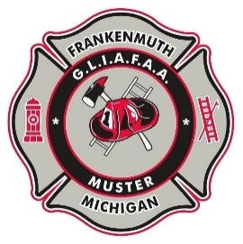
THE GREAT LAKES CHAPTER of S.P.A.A.M.F.A.A. INVITES YOU TO JOIN FUN & FELLOWSHIP AT THE

29th Anniversary 2026 MUSTER
FRIDAY, JULY 24 & SATURDAY JULY 25
HERITAGE PARK - FRANKENMUTH, MI

NAME _______________________________________________________E-MAIL:_____________________________________

ADDRESS ___________________________________________________SPOUSE:_____________________________________

CITY ___________________________ STATE ______________ ZIP ______________ CELL PHONE (_____) _____-_______

APPARATUS DESCRIPTION:

YEAR: __________ MAKE: ___________________ TYPE: _____________________ RIG NAME _____________________

YEAR: __________ MAKE: ___________________ TYPE: _____________________ RIG NAME _____________________

YEAR: __________ MAKE: ___________________ TYPE: _____________________ RIG NAME _____________________

(If needed, please list additional Rigs on separate sheet of paper and attach)

Schedule of Muster Events:
FRIDAY: 2:00 pm to 5:00 pm registration
EVENT: Food will be available for purchase near the Pavilion from 5pm – 7pm.
Cash or Venmo accepted.
Come join good food and fellowship prior to the Night Cruise and light show!!
At dusk: Night Cruise and light show with pumping option

Saturday: 8:00 to 10:00 am registration – 10:30 am Driver’s Meeting – 10:45 am Parade Line Up
11:00 am – Parade through Frankenmuth with Opening Ceremonies and Flag Raising to follow
Mass Pumping - Fire Flea Market - On Site Concession

INSURANCE STATEMENT

APPARATUS ENTRIES WILL NOT BE ACCEPTED UNLESS THIS SECTION IS COMPLETED AND SIGNED!

Insurance Carrier (Company Name) __________________________________________________________

Policy Number _______________________ Effective Date ___/___/_____ Expiration Date ___/___/_____

The apparatus I am entering will be in sound mechanical condition, roadworthy as required by the State in which the apparatus is registered and will carry public liability and property damage insurance, as indicated by the policy number above, for the day of the muster and for any time that the apparatus may be on muster grounds. I agree to hold GLIAFAA, SPAAMFAA®, INC and the City of Frankenmuth harmless for any liability I/We incur. Each piece of apparatus will have a working 5lb. ABC Fire Extinguisher and be equipped with and use two wheel chocks. The consumption of alcohol on the apparatus, in motion or stationary is prohibited. I will comply with SPAAMFAA & GLIAFAA safety guidelines and Chapter Bylaws. NOTE: All golf carts and similar electric/gas powered utility/recreational vehicles shall only be operated by a licensed driver and be covered by liability insurance.

Signature: _______________________ Print Name:___________________________ Date _ __/___/_____
Turn over for additional registration.

Apparatus Pre-Registration GLIAFAA Member Fee $25.00 $_____________
Note price differences between GLIAFAA Members and Non-Members
Apparatus Pre-Registration Non-Member Fee $30.00 (deadline July 10) $_____________
(No charge for additional apparatus)

Apparatus Registration Fee (Member or Non-Member) after July 10 deadline $35.00 $_____________

Golf Cart $10.00 Registration - must be insured $_____________

Pre-Registered Flea Market Space (outdoor only) # of space(s) _____ x $35.00 = ___________
**Bring your own tables, chairs & cover**

Registration for Flea Market after July 10 deadline # of space(s) _____ x $45.00 = ___________
Space assignment will be at club discretion.

Muster “T” shirt
ALTERNATE COLOR SHIRT
Plum Rose
Small _____ @ $18.00
Medium _____ @ $18.00
Large _____ @ $18.00
X Large _____ @ $18.00
2XL _____ @ $20.00
3XL _____ @ $21.00
4XL _____ @ $23.00

YOUTH SHIRT
Sand Color
X Small _____ @ $18.00
Small _____ @ $18.00
Medium _____ @ $18.00
Large _____ @ $18.00
XL _____ @ $20.00
MUSTER SHIRT
Sand Color
Small _____ @ $18.00
Medium _____ @ $18.00
Large _____ @ $18.00
X Large _____ @ $18.00
2XL _____ @ $20.00
3XL _____ @ $21.00
4XL _____ @ $23.00

Muster Shirts Total $ ___________

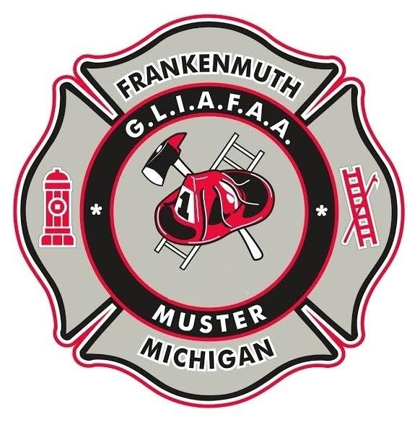
REGISTRATION DEADLINE: July 10, 2026

TOTAL ENCLOSED (US Funds Only) $___________

Any other registration arrangements MUST be made with
Eileen Moelker at Eileen.moelker@gmail.com.

Any other inquiries please contact either
Bill Rausch at br3612345@gmail.com or
Ken Tappen at firetaterrhfd@comcast.net (810-512-4044)

Please make check payable to GLIAFAA
and send completed form to:
Frankenmuth Muster
Eileen Moelker
6882 Joal Street
DEADLINE: JULY 10, 2026
Avoid extra charges and sold out shirts!

Allendale, MI 49401

