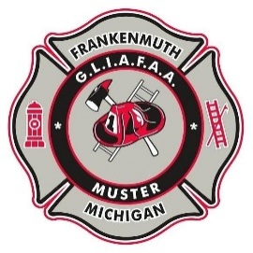
THE GREAT LAKES CHAPTER of S.P.A.A.M.F.A.A. INVITES YOU TO JOIN FUN & FELLOWSHIP AT THE

25th Anniversary 2022 MUSTER
FRIDAY, JULY 29 & SATURDAY JULY 30
HERITAGE PARK - FRANKENMUTH, MI

NAME _______________________________________________________E-MAIL:_____________________________________

ADDRESS ___________________________________________________SPOUSE:_____________________________________

CITY ___________________________ STATE ______________ ZIP ______________ CELL PHONE (_____) _____-_______

APPARATUS DESCRIPTION:

YEAR: __________ MAKE: ___________________ TYPE: _____________________ RIG NAME _____________________

YEAR: __________ MAKE: ___________________ TYPE: _____________________ RIG NAME _____________________

YEAR: __________ MAKE: ___________________ TYPE: _____________________ RIG NAME _____________________

(If needed, please list additional Rigs on separate sheet of paper and attach)

Schedule of Muster Events:

Friday: 2:00 pm to 5:00 pm registration – 5:00-7:00 pm Chicken Dinner

Saturday: 8:00 to 10:00 am registration – 10:30 am Driver’s Meeting – 10:45 am Parade Line Up
11:00 am – Parade through Frankenmuth with Opening Ceremonies and Flag Raising to follow
Mass Pumping - Fire Flea Market - On Site Concession

INSURANCE STATEMENT

APPARATUS ENTRIES WILL NOT BE ACCEPTED UNLESS THIS SECTION IS COMPLETED AND SIGNED!

Insurance Carrier (Company Name) __________________________________________________________

Policy Number _______________________ Effective Date ___/___/_____ Expiration Date ___/___/_____

The apparatus I am entering will be in sound mechanical condition, roadworthy as required by the State in which the apparatus is registered and will carry public liability and property damage insurance, as indicated by the policy number above, for the day of the muster and for any time that the apparatus may be on muster grounds. I agree to hold GLIAFAA, SPAAMFAA®, INC and the City of Frankenmuth harmless for any liability I/We incur. Each piece of apparatus will have a working 5lb. ABC Fire Extinguisher and be equipped with and use two wheel chocks. The consumption of alcohol on the apparatus, in motion or stationary is prohibited. I will comply with SPAAMFAA & GLIAFAA safety guidelines and Chapter Bylaws. NOTE: All golf carts and similar electric/gas powered utility/recreational vehicles shall only be operated by a licensed driver and be covered by liability insurance.

Signature: _______________________ Print Name:___________________________ Date _ __/___/_____

Turn over for additional registration.

Apparatus Pre-Registration GLIAFAA Member Fee $15.00 $_____________
Note price differences between GLIAFAA Members and Non-Members
Apparatus Pre-Registration Non-Member Fee $20.00 (deadline July 21) $_____________

Second Apparatus Pre-Registration Fee $5.00 (deadline July 21) $_____________
(No additional charge for more than two rigs)

Apparatus Registration Fee (Member or Non-Member) after July 21 deadline $25.00 $_____________

Second Apparatus Registration Fee received after July 21 deadline $7.00 $_____________
Golf Cart $5.00 Registration (must be insured) $_____________

Chicken Dinner Friday evening 5:00 – 7:00 PM ______ x $12.00= ___________

Pre-Registered Flea Market Space (outdoor only) # of space(s) ______ x $20.00 = ___________
**Bring your own tables, chairs & cover**

Registration for Flea Market after July 21 deadline # of space(s) ______ x $30.00 = ___________
Space assignment will be at club discretion.

Friday Events
Chicken Dinner from 5:00 PM – 7:00 PM – Pre-order tickets @$12.00 each
Come for a time of fellowship and meeting new people!
Heritage Park under the pavilion.

Muster “T” shirt
MUSTER SHIRTS
Small _____ @ $15.00 2XL _____ @ $17.00
Medium _____ @ $15.00 3XL _____ @ $18.00
Large _____ @ $15.00 4XL _____ @ $20.00
X Large _____ @ $15.00
Muster Shirts $ ______________

REGISTRATION DEADLINE: July 21, 2022

TOTAL ENCLOSED (US Funds Only) $___________
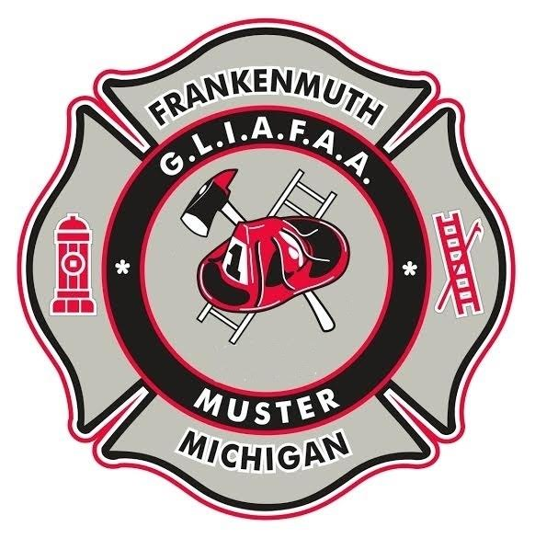
Contact Bill Rausch at br3612345@gmail.com
or call 248-625-8924 for more information.

Registration deadline: July 21, 2022

Please Make Check Payable to GLIAFAA
and send completed form to:

Frankenmuth Muster
Eileen Moelker
6882 Joal Street
Allendale, MI 49401

E-Mail: eileen.moelker@gmail.com

